ReactJS Hands-on 19 - Unit Testing and Mocking

Project Structure

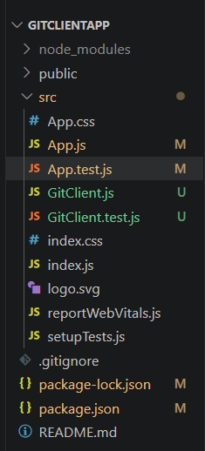

Commands
npx create-react-app gitclientapp
cd gitclientapp
npm install axios
npm install --save-dev jest axios-mock-adapter
npm start
npm test

GitClient.js
import axios from "axios";
class GitClient {
static getRepositories(userName){
const url=`https://api.github.com/users/${userName}/repos`;
return axios.get(url);
}
}
export default GitClient;

App.js
import './App.css';
import {useEffect,useState} from 'react';
import GitClient from './GitClient';
function App(){
const [repositories,setRepositories]=useState([]);
useEffect(()=>{
GitClient.getRepositories("techiesyed")
.then(response=>setRepositories(response.data));
},[]);
return(
<div className="App">
<h1>Git repositories of User - TechieSyed</h1>
{repositories.map(repo=><p key={repo.name}>{repo.name}</p>)}
</div>
);
}
export default App;

GitClient.test.js
import axios from "axios";
import MockAdapter from "axios-mock-adapter";
import GitClient from "./GitClient";
describe("Git Client Tests",()=>{
const mock=new MockAdapter(axios);
test("should return repository names for techiesyed",async()=>{
const repositories=[{name:"RepoOne"},{name:"RepoTwo"},{name:"RepoThree"}];
mock.onGet("https://api.github.com/users/techiesyed/repos").reply(200,repositories);
const response=await GitClient.getRepositories("techiesyed");
expect(response.data).toEqual(repositories);
});
});

App.test.js
import {render,screen} from '@testing-library/react';
import App from './App';
test('renders Git repositories heading',()=>{
render(<App/>);
expect(screen.getByText(/Git repositories of User - TechieSyed/i)).toBeInTheDocument();
});

Output

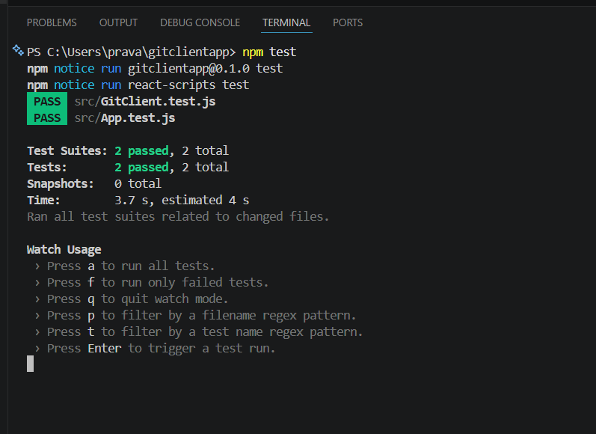

Browser Output
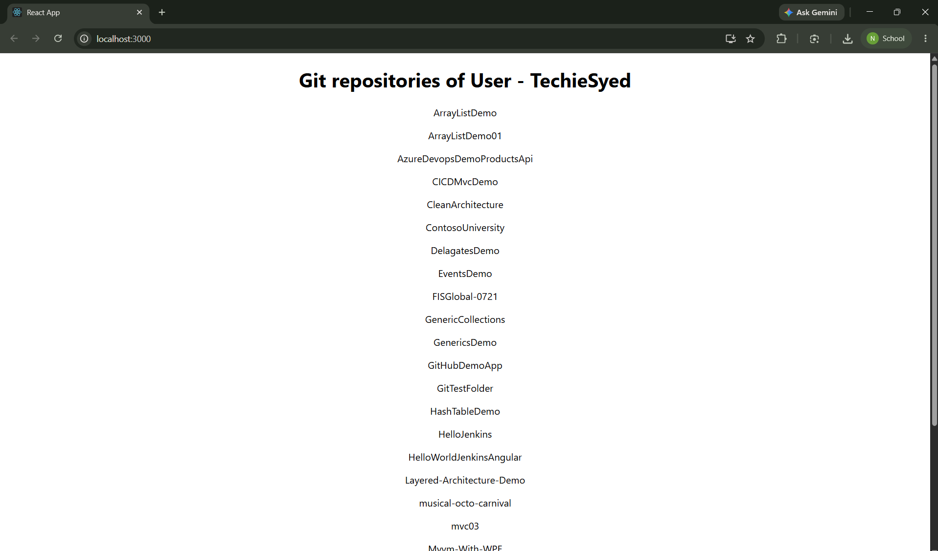

Conclusion
The application successfully fetched GitHub repositories and all unit tests passed using mocked Axios responses.

